ABHINAV RANJAN

RA1911003010003

CSE A1 SECTION

SRMIST , KTR

**COMPILER DESIGN LAB**

***EXP 10 - INTERMEDIATE CODE GENERATOR***

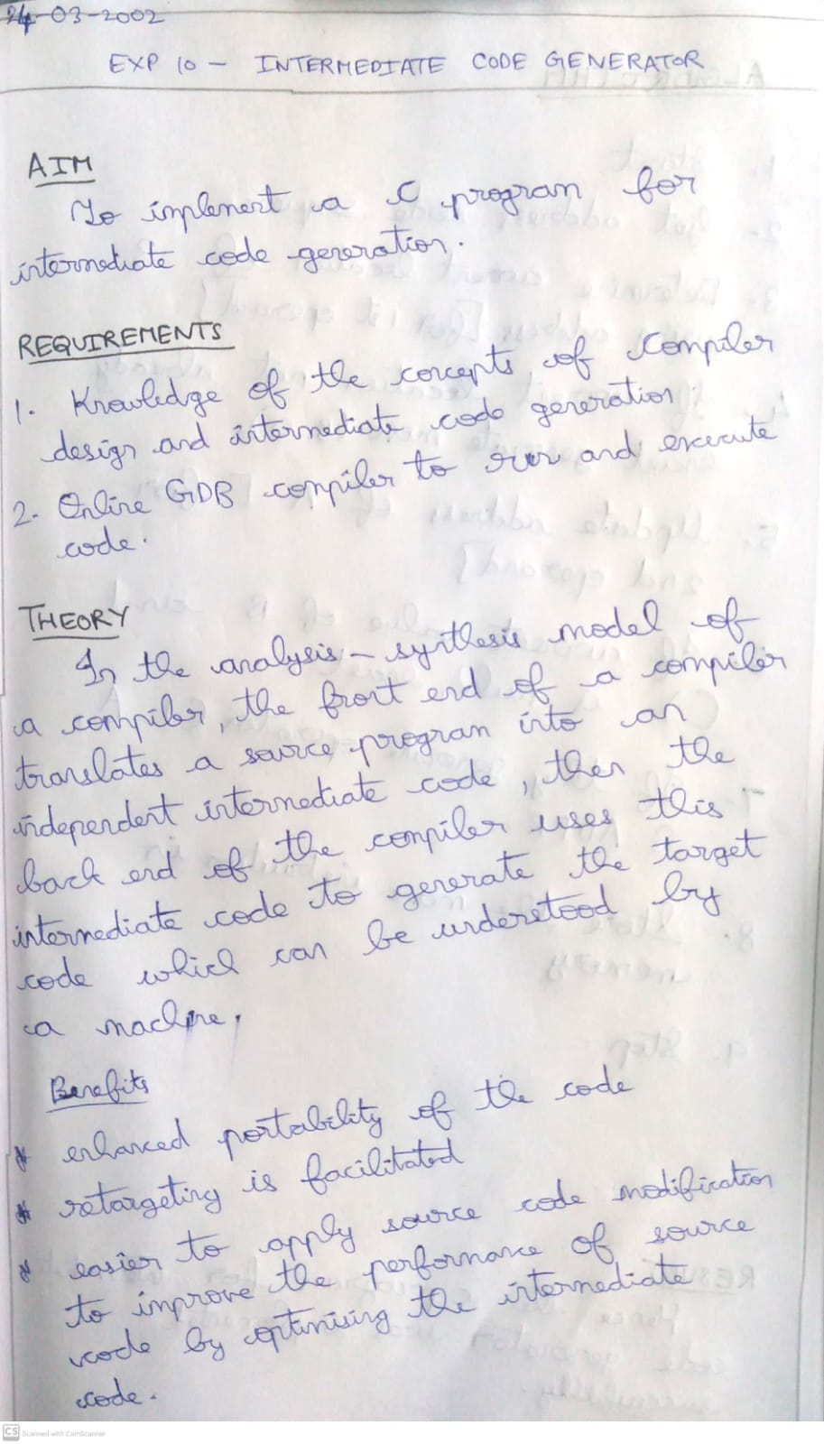

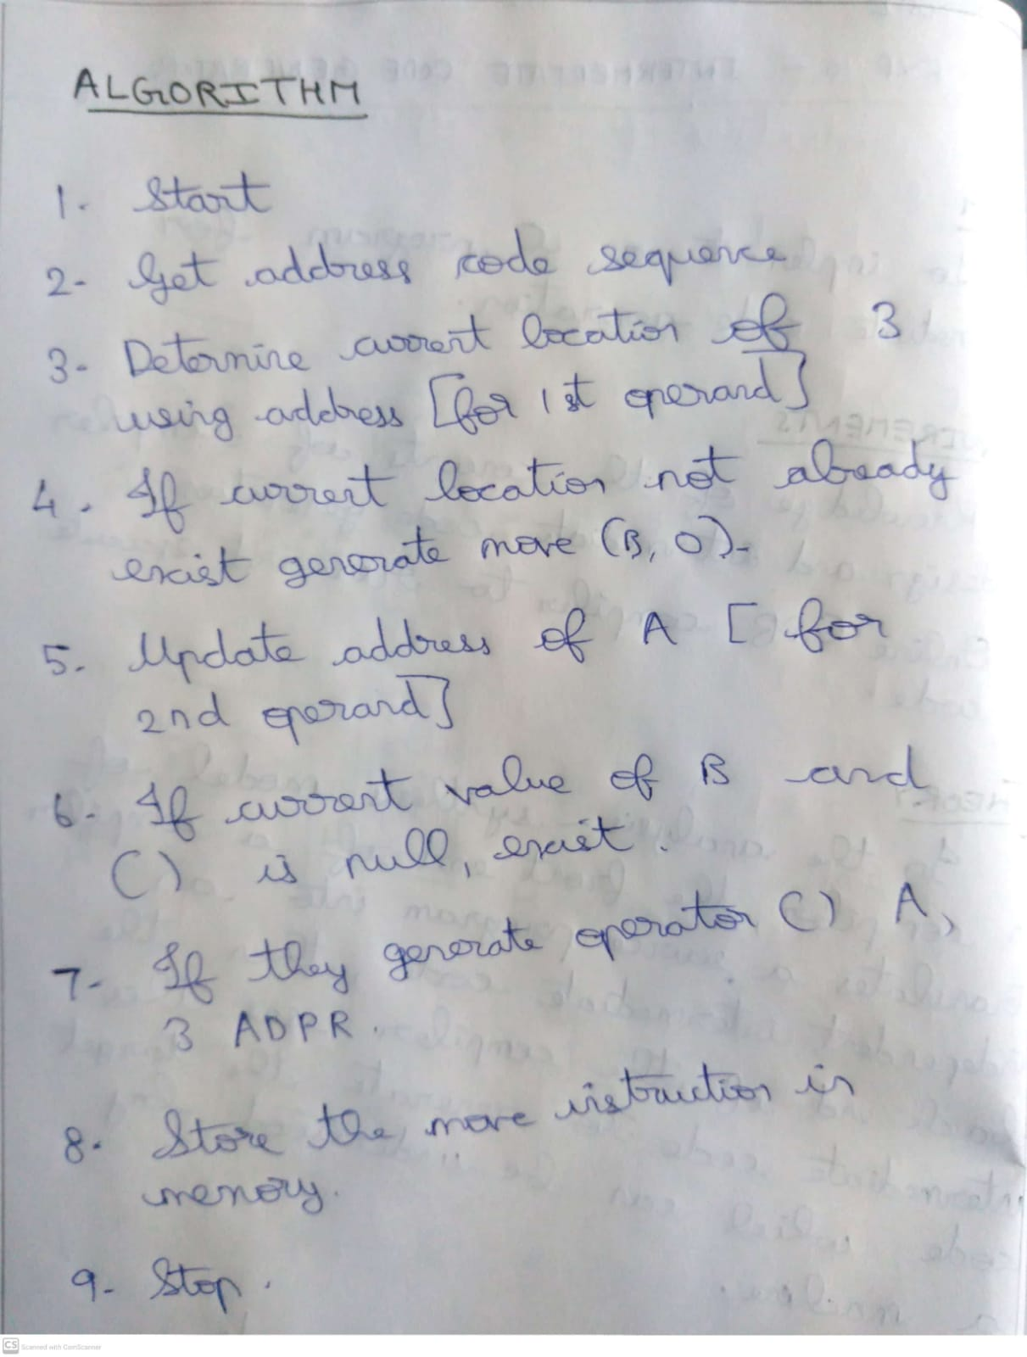

**SCREENSHOTS :**

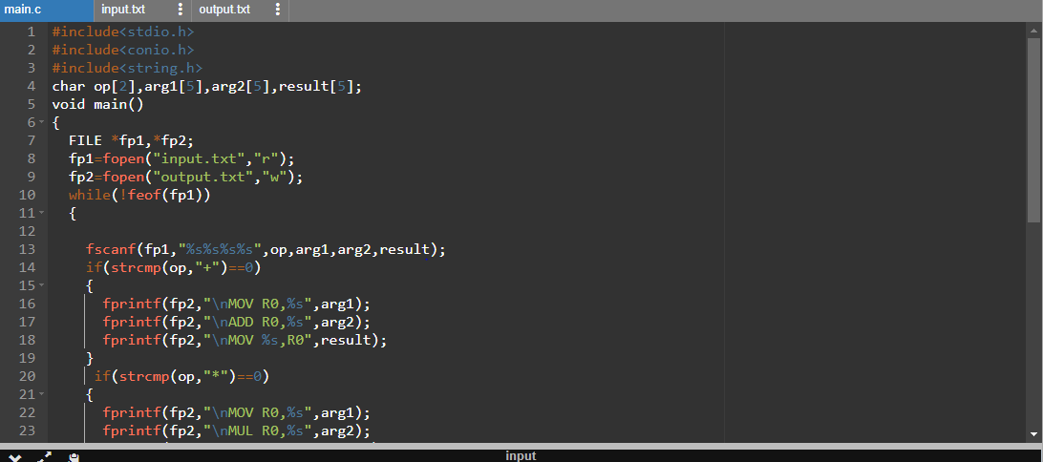

**INPUT FILE :**

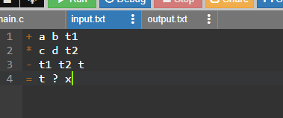

**OUTPUT FILE:**



